

**OPEN SOURCE PROJECT (INT 301)**

SUBMITTED TO: SUBMITTED BY:

**Shivali Chopra** **B Pankaj Kumar**

Reg. No: **11605953**

Roll no: **A17**

Section: **KE009**

Please go to this GitHub link to see the screenshots and the code:

<https://github.com/Pankajlpu/myprojectost>

**PROBLEM STATEMENT:**

Q7: Consider a php form with columns_id, first_name, last_name, email_id. Insert the following data in the database and fetch all the data in descending order of first_name.

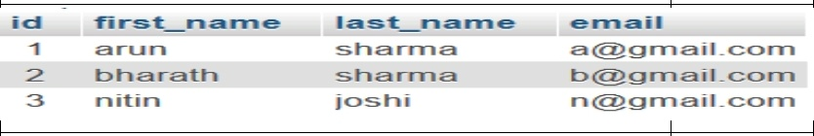

**#SOLUTION:**

PHP is scripting language which does run directly on browser and for running them you need to setup a server or use online server. For local server I will be using **APACHE** and **PHP** and for the creation of database I will be using **MYSQL** and all these technologies will be used through **XAMPP**.

**#PREREQUISITES:**

* APACHE
* PHP
* MySQL

**#INSTALLING PREREQUISITES AND PRECODURE:**

* First we need to install XAMPP server.
* Then in XAMPP CONTROL PANEL we need to run Apache and MySQL.
* After that we need to open phpMyAdmin by clicking the Admin option next to the start button of MySQL in XAMPP CONTROL PANEL.

Link: <http://localhost:8080/phpmyadmin/>

* In phpMyAdmin we need to create a database and a table and later insert values into the table.
* Then created a database named **‘my_database’** and a table named **‘data’** and inserted values into the table.

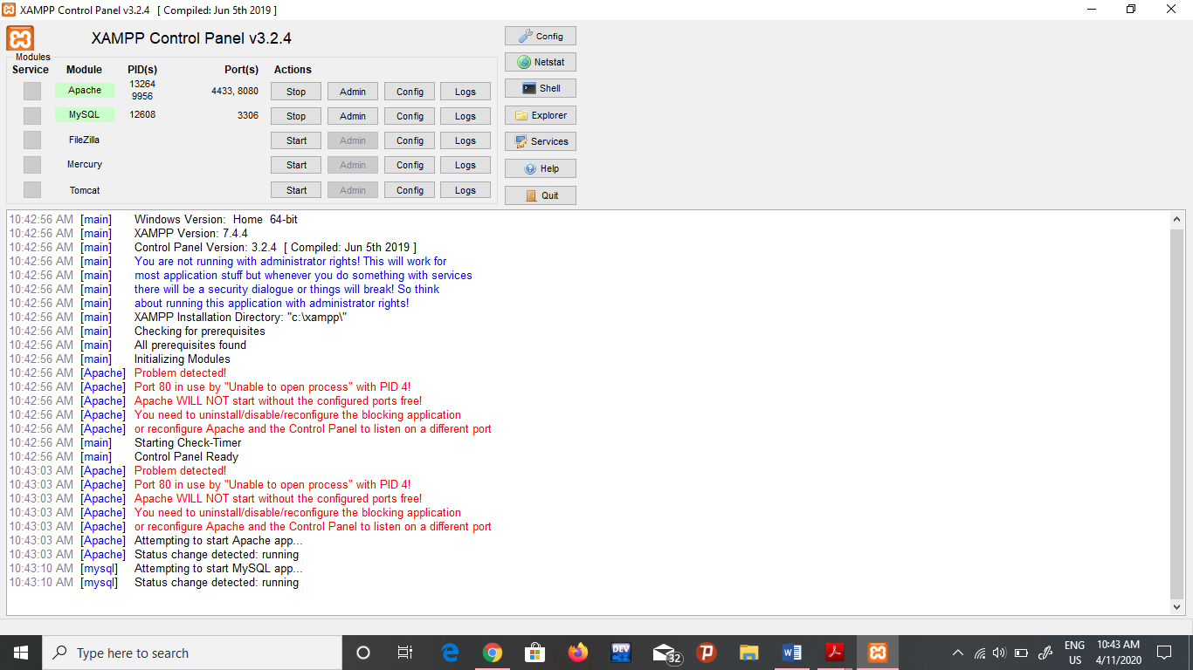

Fig: 1. XAMPP Control Panel

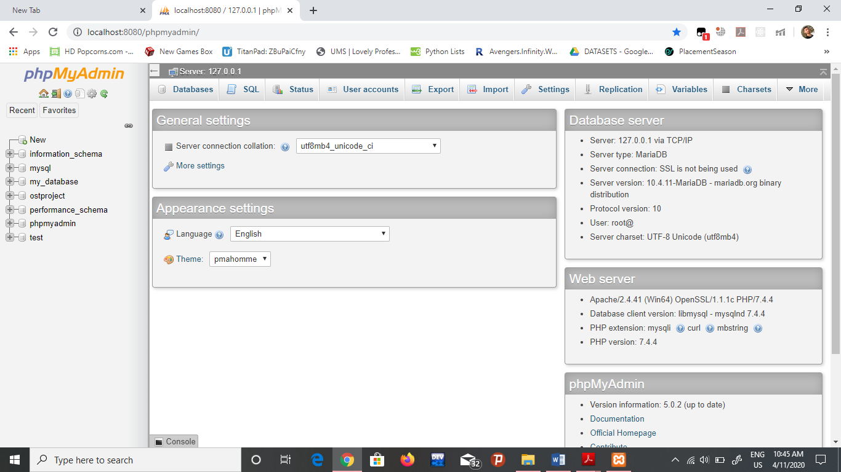

Fig: 2. phpMyAdmin Login Page

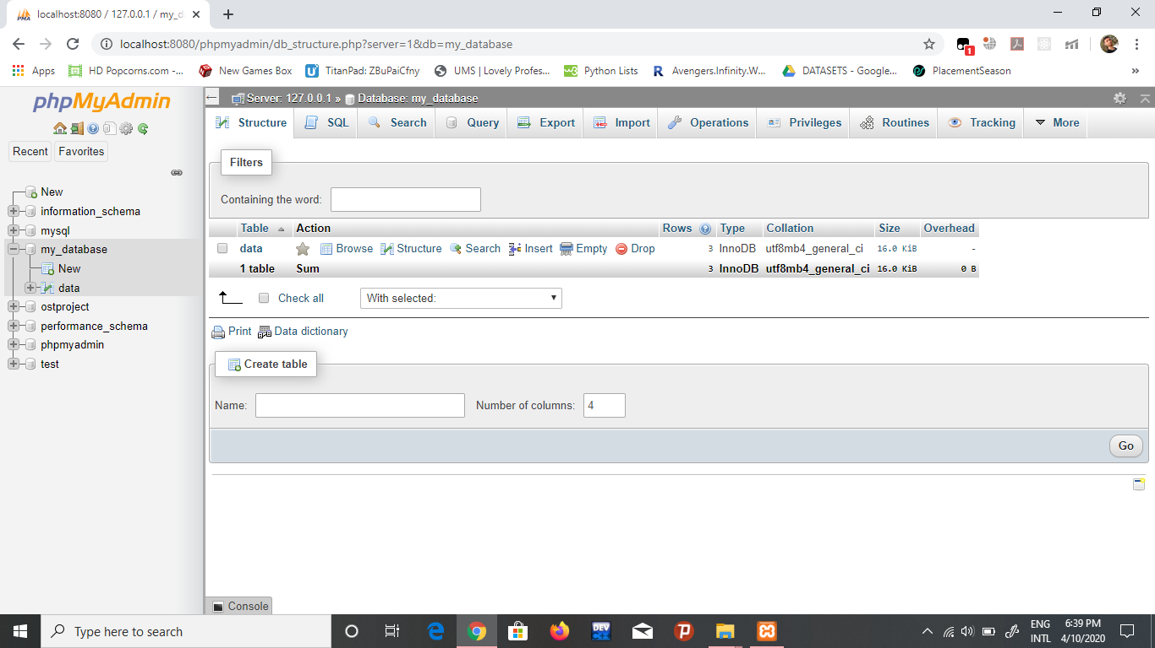

Fig: 3. Creating a database **‘my_database’**

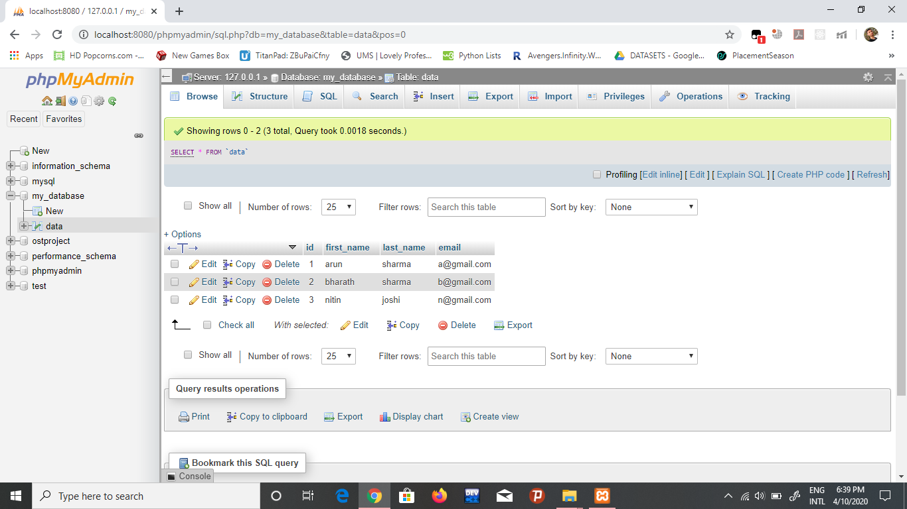

Fig: 4. Creating a table **‘data’** and inserting values in it.

**#CONNECTING THE DATABASE:**

In order to display the output on the localhost, first we need to make a connection to the database and the code to connect to the database using PHP is as follows:

<?php

$servername = "localhost";

$username = "root";

$password = "123";

$dbname = "my_database";

$datatable = "data";

$results_per_page = 3;

$conn = new mysqli($servername, $username, $password, $dbname);

if ($conn->connect_error) {

die("Connection failed: " . $conn->connect_error);

}

?>

<?php

**#FETCHING THE GIVEN DETAILS IN THE DESCENDING ORDER:**

<?php

if (isset($_GET["page"])) { $page = $_GET["page"]; } else { $page=1; };

$start_from = ($page-1) * $results_per_page;

$sql = **"SELECT * FROM data ORDER BY first_name DESC LIMIT $start_from, "**.$results_per_page;

$rs_result = $conn->query($sql);

?>

<table border="1" cellpadding="40">

<tr>

<td bgcolor="#FF8C00"><strong>ID</strong></td>

<td bgcolor="#FF8C00"><strong>First_Name</strong></td>

<td bgcolor="#FF8C00"><strong>Last_Name</strong></td>

<td bgcolor="#FF8C00"><strong>Email</strong></td></tr>

<?php

while($row = $rs_result->fetch_assoc())

{

?>

<tr>

<td><?php echo $row["id"]; ?></td>

<td><?php echo $row["first_name"]; ?></td>

<td><?php echo $row["last_name"]; ?></td>

<td><?php echo $row["email"]; ?></td>

</tr>

<?php

};

?>

</table>

After writing the above code we need to click the below link to get the final output:

Link: <http://localhost:8080/connecting%20to%20a%20database/project.php>

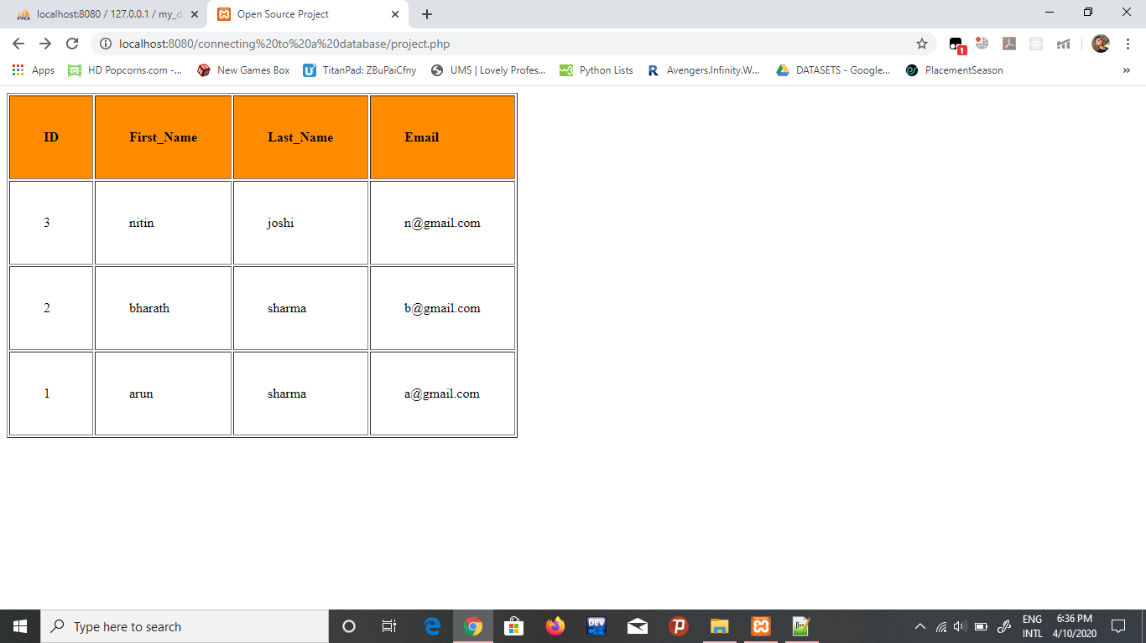

Fig: 5. Getting the output i.e. in descending order.